MAIN CHANGE: SENTIA

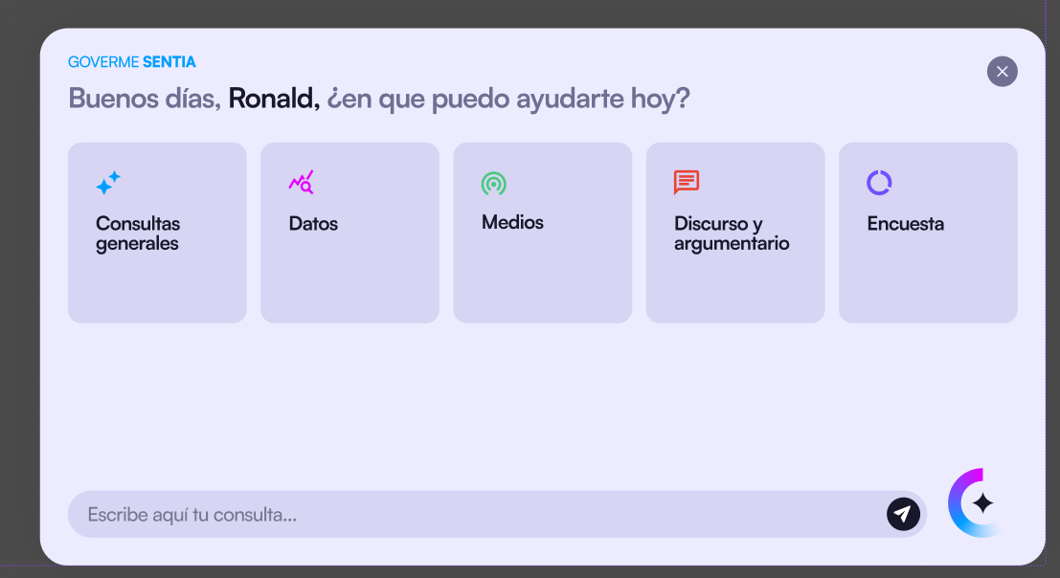

Sentia is available in every screen of the tool, as an assistant in the corner of the screen that has to be connected to the streaming API to make consultations of various types (general, data, historical media news, improve speeches) and launching surveys from there.

MAIN CHANGE: Survey Results

Any survey launched must have the results generated by the AI streamed into this results pages summarizing the results from people’s replies.

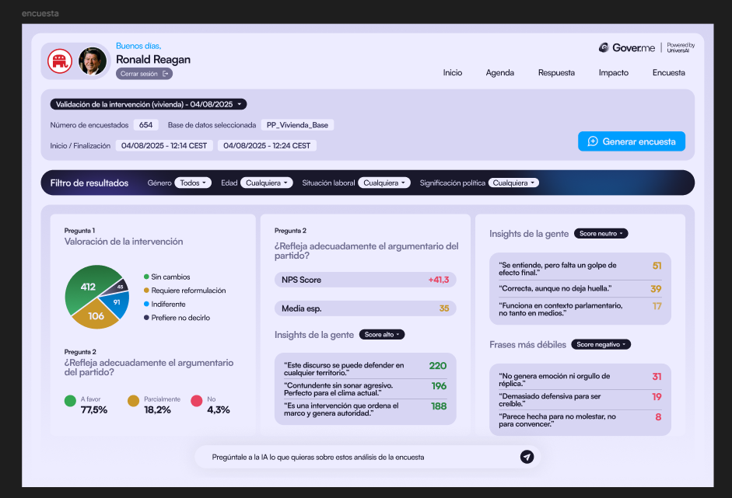

MAIN CHANGE: IMPROVE LIVE ANSWER

Live answer was almost finalized, but must be improved to be working fully.

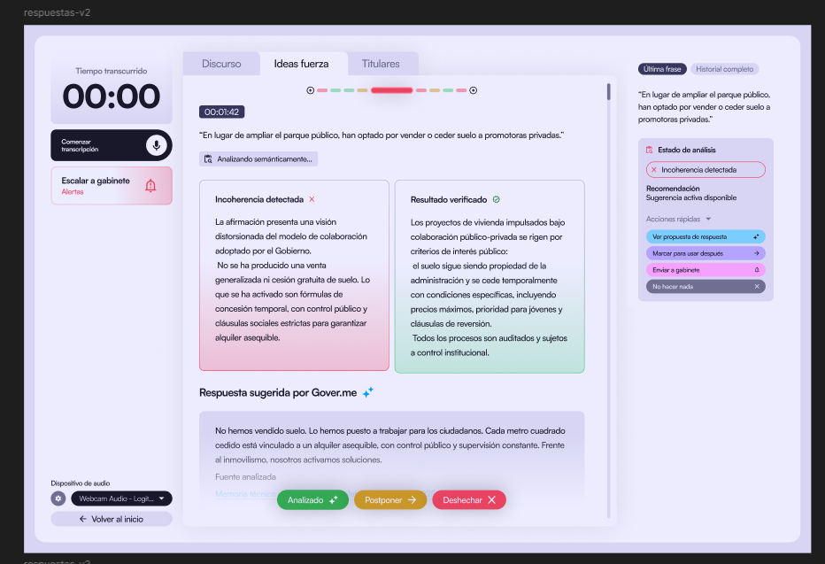

MINOR CHANGE: NAME AND TITLE

MINOR CHANGE: SCREENS ORDER:

The goal is that Sentia and the main functionalities (media, live reply etc.) are always functional and accessible whenever is needed.

MINOR CHANGE: TEXT CHANGES

